Now let’s take an example of model predicting stock pricings.

Suppose we trained the model using last 10 days data and tried to predict for D11 and we got auc of some 0.8.

It’s fairly good and on D12 it was 0.81 it’s also good.

But on D13 it dropped to 0.6 which means now you need to retrain your data using latest data so that the model can be better for current day scenerios.

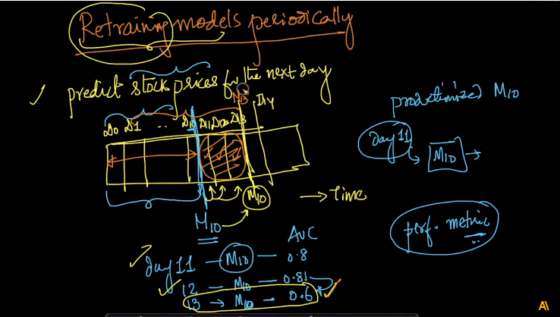

So now the question is how to determine when to retrain data?

It can be regularly if the cost of retrain is not much and regularly may differ in situations i.e. may be daily, hourly, weekly, or in minutes.

But if cost is much than we can check if the model performance is decreasing so we retrain the model.

Than if the data is changing i.e. the distribution of dataset changes or say data is not stationary then we need to retrain the model.

